LAB EXPERIMENT RECORD
Set 10 – Survey Responses Analysis
Department | AI&DS
Course Code / Course Name | DSA0602 / Data Handling and Visualization
Experiment | Data Visualization using R
Name | DEVAMADA HEMASREE
Register Number | 192524114
Date | 06 OCTOBER 2026
Day | FRIDAY

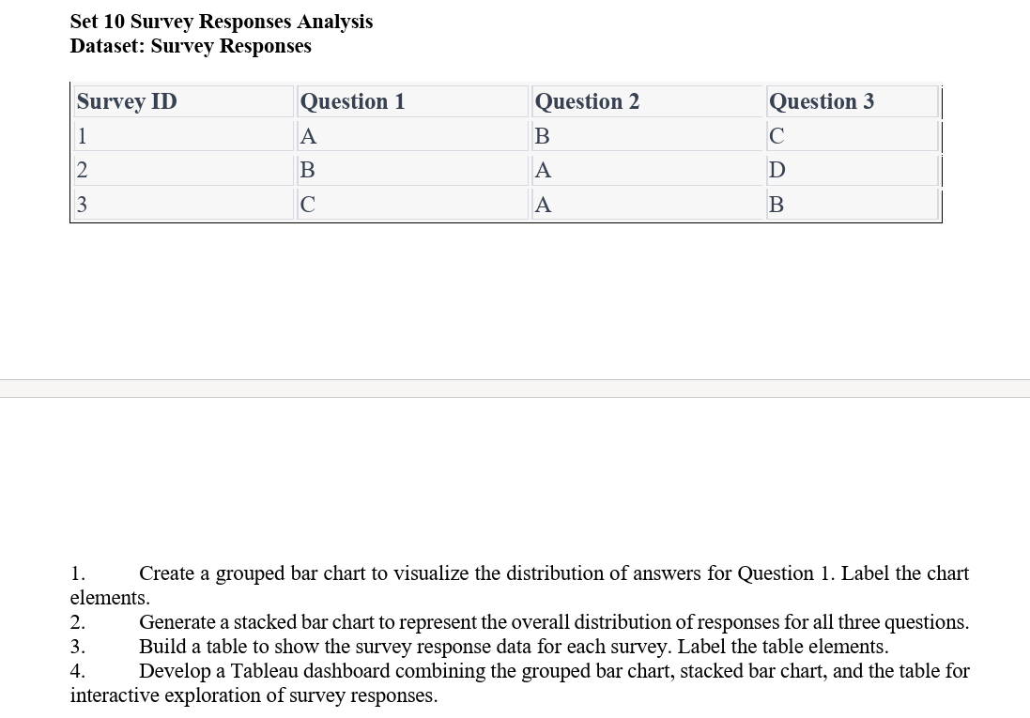

1. Grouped Bar Chart
Aim:
To create a grouped bar chart to visualize the distribution of answers for Question 1.
Code:
# Survey data
survey_id <- c(1, 2, 3)
q1 <- c("A", "B", "C")

# Count responses
responses <- table(q1)

# Grouped bar chart
barplot(responses,
main = "Distribution of Question 1 Answers",
xlab = "Answers",
ylab = "Number of Responses",
col = "skyblue")
Output:
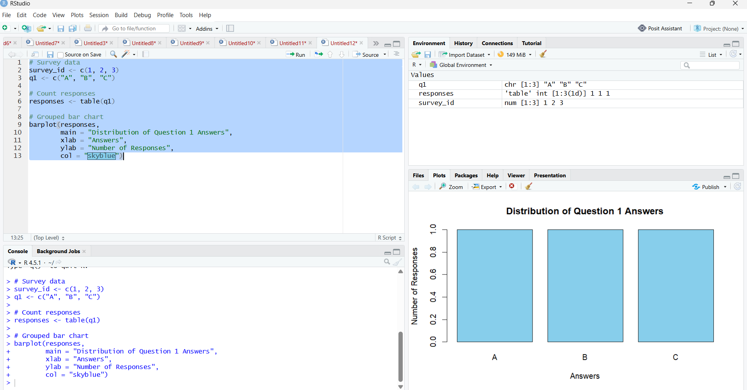

2. Stacked Bar Chart
Aim:
To create a stacked bar chart representing the overall distribution of responses for all three questions.
Code:
# Survey data
q1 <- c("A", "B", "C")
q2 <- c("B", "A", "A")
q3 <- c("C", "D", "B")

# Create response counts
responses <- rbind(
Question1 = table(factor(q1, levels = c("A","B","C","D"))),
Question2 = table(factor(q2, levels = c("A","B","C","D"))),
Question3 = table(factor(q3, levels = c("A","B","C","D")))
)

# Stacked bar chart
barplot(responses,
beside = FALSE,
main = "Overall Distribution of Survey Responses",
xlab = "Answers",
ylab = "Number of Responses",
col = c("skyblue", "orange", "lightgreen"))
Output:
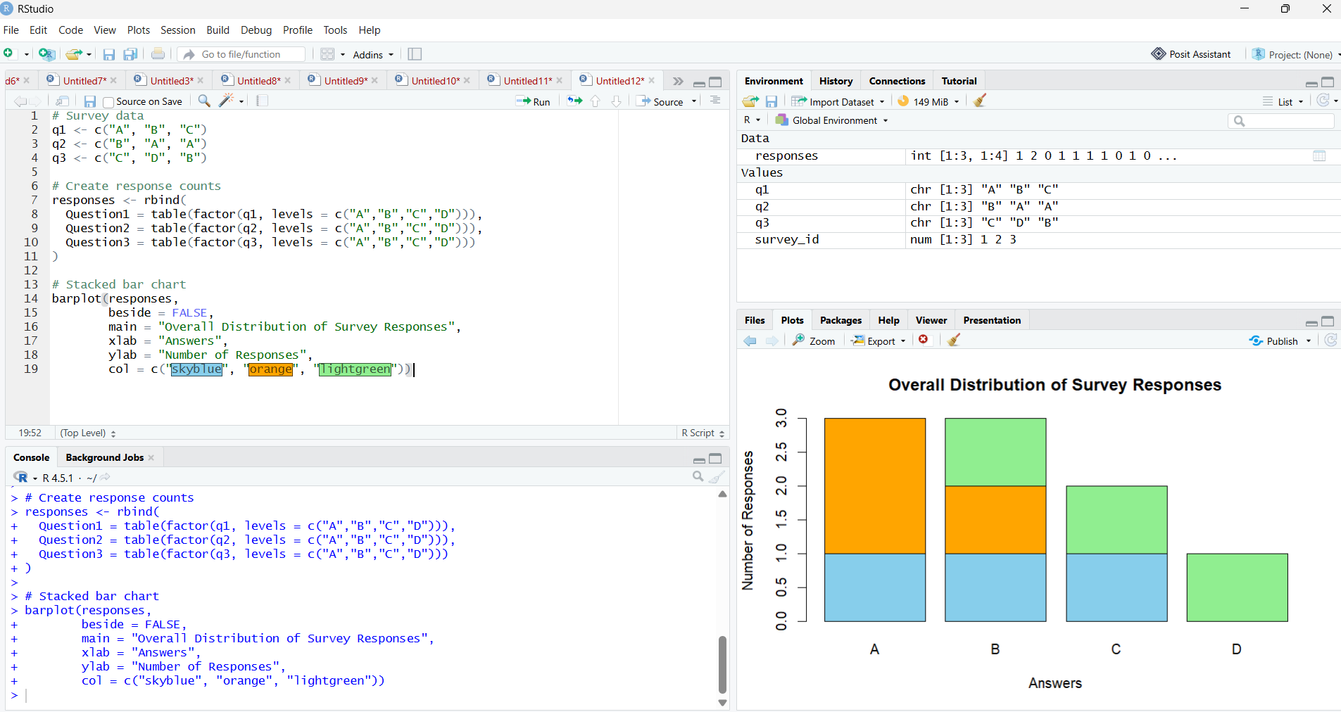

3. Table
Aim:
To create a table displaying the survey response data for each survey.
Code:
# Survey response data
survey <- data.frame(
Survey_ID = c(1, 2, 3),
Question_1 = c("A", "B", "C"),
Question_2 = c("B", "A", "A"),
Question_3 = c("C", "D", "B")
)

# Display table
print(survey)

Output:
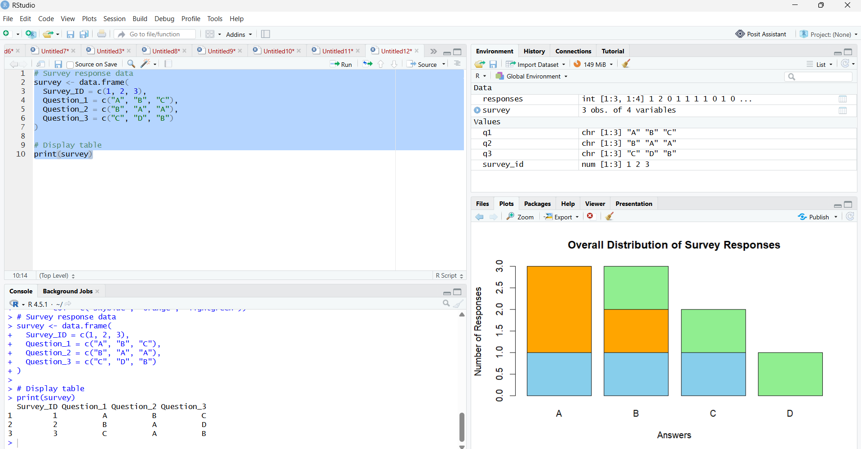

4. Tableau Dashboard
Aim:
To develop a Tableau dashboard combining the grouped bar chart, stacked bar chart, and table for interactive exploration of survey responses.
Output:
